**Reception Knowledge Organiser  
Summer 2: Are all minibeasts scary?**

As we end our Reception journey, this half term we will be focussing on minibeasts. This topic enables exploration of the outdoor area and use of scientific equipment. Children can learn how to attract minibeasts to the outdoor area and the importance of minibeasts in the environment.

**Our focus books this half-term**

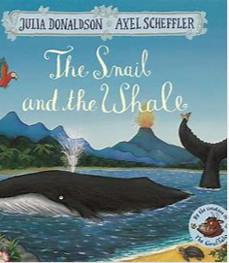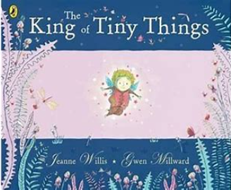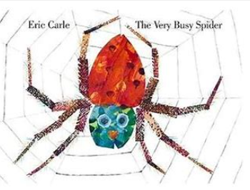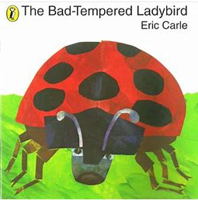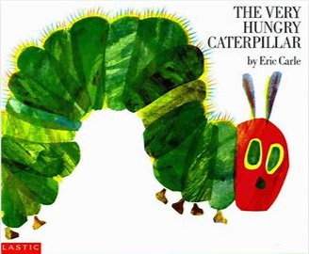

**Key Vocabulary**

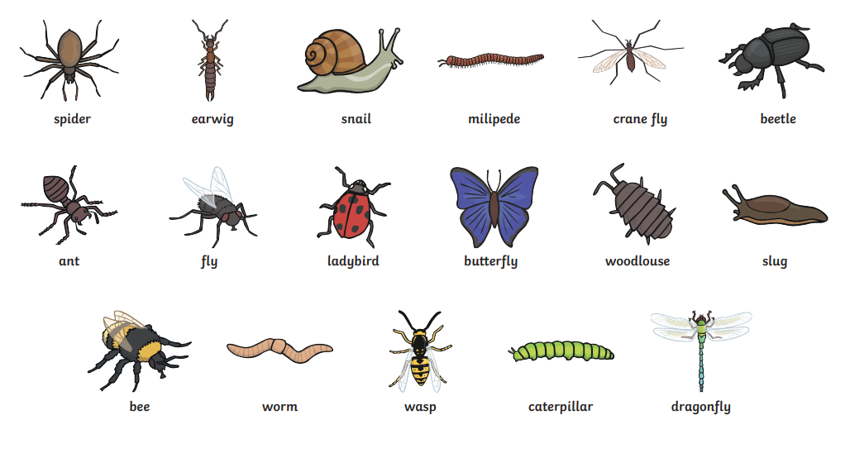

**Ideas for at home**

* Take a walk around a garden, park or outside area. What minibeasts can you find? Try looking under plant pots or stones, looking on leaves, bushes or around some flowers. You could draw a picture or take a photograph of what you find.
* Practise ‘Incy Wincy Spider’ with actions.
* Try to make a model minibeast!

**Key Questions**

* Why does a spider need a web?
* Where did the butterfly come from?
* Does a worm have legs?
* Why does a snail carry its house around?
* Why does a ladybird have spots?
* Do minibeasts have birthdays?