What? (Key Knowledge)
Where we live | We live in the town Widnes. Widnes is located in the north west of England which is part of the United Kingdom. There are four countries of the United Kingdom: England, Northern Ireland, Scotland and Wales.
Our school | Our school is in the local area, Farnworth in Widnes.
Geographical Skills and Fieldwork
- Label an aerial view picture of our school and local area to show where everything is using symbols and a key.
- Go on a local walk to learn about the geography of the school, its grounds and the key human and physical features of its surroundings.
- Use Digi-maps to locate key places in our local area using OS maps.
- Give instructions on how to get from one place to another using near/far and right/left.
- Describe where something is using the four compass points: north, south, east and west.
What? (Key Vocabulary)
Spelling |  | Definition/ Sentence
aerial view |  | A view from above.
compass |  | An instrument with a needle that always points North.
symbol |  | A sign, number or letter that has a meaning
map |  | A drawing of a place e.g. a town, country or the world.
human feature |  | Things built by humans: town, tunnel, bridge
physical feature |  | Natural features of the Earth; mountain, river, desert,
route |  | The way you go to get to a place.
key |  | An explanation of the symbols used on a map or plan.
direction |  | Where someone or something is pointing or moving
location |  | A place where something is.
fieldwork |  | Practical research that takes place outside.
Diagrams and Symbols
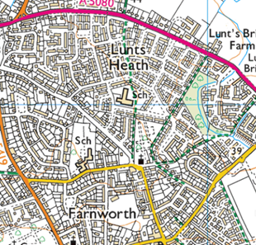

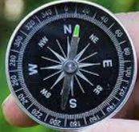

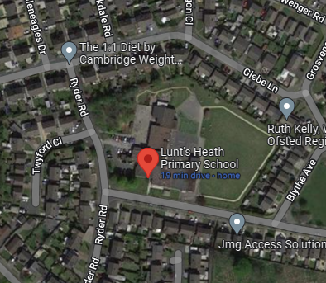

Aerial view of Local Area
