When? (Time line)
55BC | The first invasion of Britain was led by Julius Caesar but he failed
54BC | Julius Caesar came back. But again he didn't conquer South-England.
AD 43 | The second invasion was led by Claudius and he was successful
AD 50 | London is founded
AD 60 | Tribes led by Boudicca attack roman forces
AD122 | Hadrian’s Wall completed
AD 410 | Romans leave Britain and return to Italy
Roman Empire
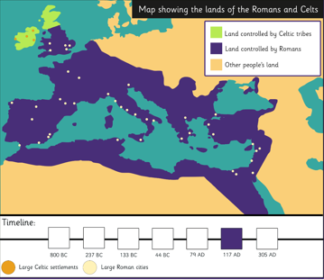
Romans originate from Italy and the city of Rome.
Reasons the Romans invaded Britain
Resources e.g. tin, copper.
Power, Ambition, Revenge, Slaves
Who? Famous People
Emperor Claudius |  |  | First Roman Emperor to successfully invade Britain
Julius Caesar |  |  | Famous Roman leader who attempted to invade Britain
Boudicca |  |  | A queen of the Celtic Iceni tribe who led an uprising against Roman occupied towns & cities.
Paulinus |  |  | Roman governor (ruler) of Britain in AD60
Spelling |  |  | Definition
century |  |  | 100 years
decade |  |  | 10 years
empire |  |  | A group of nations or peoples under one ruler or government
emperor |  |  | The male ruler of an empire
republic |  |  | A country without a king, queen or emperor. The elected Senate ruled the Roman republic.
invade |  |  | To enter as an enemy, by  force, in order to conquer
conquer |  |  | To get or overcome by force
legion |  |  | One unit of the Roman army; had 4,000 to 6,000 soldiers.
legionnaire |  |  | A member of a legion
centurion |  |  | An officer commanding about 80 legionnaires
amphitheatre |  |  | A stadium, where Romans were entertained
artefact |  |  | An object from the past
What legacy did the Roman leave behind in Britain?
Language |  | Latin, the official Roman language, forms the roots of many of our words
Names |  | We use Roman names for months (January, July) and planets (Mars, Jupiter)
Buildings |  | Public baths, amphitheatres, temples can all be seen around Britain
Hadrian’s Wall |  | A stone wall built by Emperor Hadrian to keep out the Picts/celts who kept attacking Roman towns in the north. The ruins can still be seen today.
Roman Forts |  | Forts, like Chester, were built along Roman roads, for protection. This was where legions of soldiers lived.
Roman Roads |  | Watling Street, Fosse Way are Roman roads. They are part of our road network today.
Bath Houses |  | Roman Bath Houses played an important part in Roman life.
