What? (Key Vocabulary)
Spelling | Definition/ Sentence
village | A small settlement with houses, a primary school, a few shops, a Post Office and a village hall.
Town | A settlement where people live and work. It is larger than a village, with lots of houses, primary and secondary schools, as well as sometimes having a railway station and shopping centre.
City | The largest type of settlement, containing many buildings and lots of people. They usually have hospitals, sports facilities, universities, shops, offices, many houses and a cathedral.
Land use | The way land is used for example housing area, industrial area, farmland, leisure, port, harbour, school, shopping.
rural | Countryside, farmland areas outside a towns and cities
urban | Built up areas around towns and cities
Port | An area for ships to dock, usually near a large city
county | The areas a country is divided into for government organisation. Cheshire is the small area of England
Region | A larger area of a country with definable features
Economic activity | The businesses, industry, jobs that enable people to earn money.
coordinates | A set of numbers, letters and symbols that enable location of places on maps. Used with OS maps.
What are Settlements like?
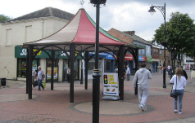
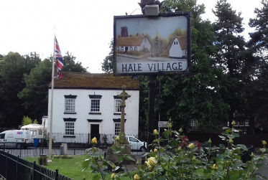
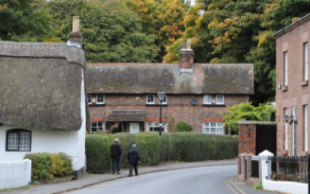
Hale Village
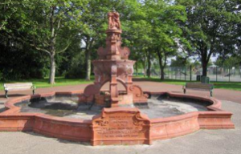
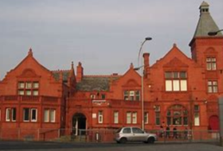
Widnes Town

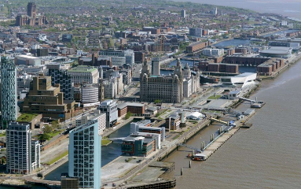
Liverpool City
Located on the River Mersey.

An Atlantic Ocean Port

How have settlements Changes over time?

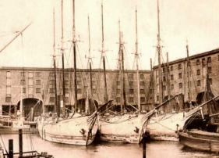
Then: Industrial warehouses and port.
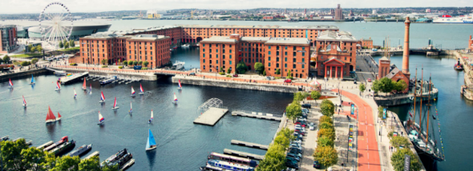
Now: Modern tourist attraction.

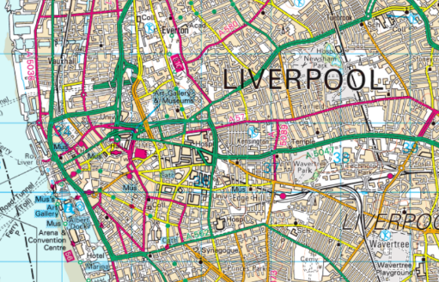
Map locations. Using OS maps, road maps, atlases
Widnes, Cheshire, North West Region, City of Liverpool
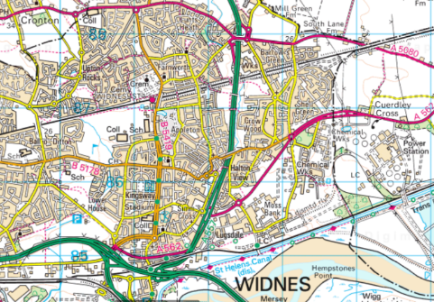
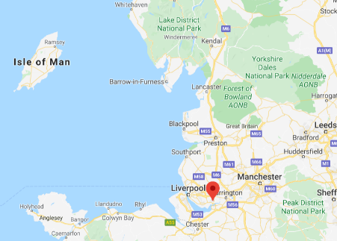
Use four-figure grid references and compass directions
Key Learning
- Know the names of and locate features in the North West of England. (Widnes, Liverpool, Manchester, River Mersey, Lake District,, Coastal areas and Blackpool.)
- Know how to plan a journey within the UK, using a road map.
- Know how industry can impact on a town or city in terms of growth and wealth.
- Understand how Liverpool’s river location enabled its growth to be a significant city in the North West
- Know and understand key aspects of human geography, including economic activity.

