**Year 5 Newsletter**

**Classes 5L and 5H  
This term the children will be exploring the following topics**:

In **Science**, we will be learning about materials. and their properties. We will look at dissolving, separating mixtures and irreversible changes. We will explore the properties of materials to find the most suitable material for different purposes. The children will work scientifically and collaboratively to investigate the best thermal insulator to make a lunch box, making predictions and forming conclusions.

In **Maths**, some of the things we will practise are:

Number: Place Value  
We will read and write numbers to 100 000, quickly moving onto numbers to 1 000 000. Time is spent using concrete materials to represent numbers to 1 000 000, including number discs and place-value charts. We will then compare numbers to 1 000 000 using our knowledge of place value.

Number: Addition and Subtraction  
We will be exploring addition and subtraction of numbers to 1 000 000. We will focus on adding within 1 000 000 and subtracting within 1 000 000 using multiple key methods, such as the column method and number bonds to add and subtract numbers. We will end with consolidation activities with number cards, putting the children’s knowledge and understanding into practice.

In **Literacy**:

We will be reading Beowulf by Michael Morpurgo.  
In reading, we will understand that a writer moves events forward through a balance of dialogue action and description. We will explore how a writer uses show and not tell techniques to introduce or develop a character and find words and language used for effect, explaining the effect and record these to use in writing.  
In writing, we will look at paragraphs with clear topic sentences which signal changes in time, place, or event. We will also look at how a topic sentence provides a link to the previous paragraph. We will identify the purpose and audience for writing and know that different text types are organised in different ways to guide the reader.

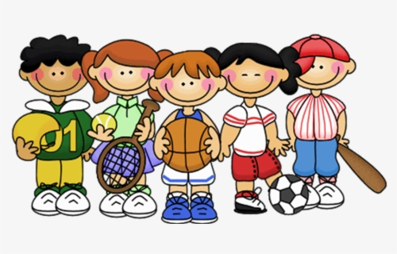

This half-term in **History** we will be exploring Anglo-Saxons and the Vikings and identify how Britain changed between the end of the Roman occupation and 1066. We will know that during the Anglo-Saxon period Britain was divided into many kingdoms which led to the creation of some of our county boundaries today.  
In **Geography**, we will be studying South America. We will know the names of, and locate, several South American countries and identify the main human and physical differences between developed and developing countries.  
In **RE**, we will explore Christianity and God looking at how Christian stories contain important truths and messages for people to learn from.   
In **Art**, we will look at Anglo-Saxon printing and how they were highly skilled craftsmen and women who created jewellery, ceramics, sculptures and wall paintings. We will use examples of their art to create precise repeating patterns by creating accurate printing blocks.

In **Music** we will be studying Rock and Pop and performing Living on a Prayer by Jon Bon Jovi.

**Messages and reminders**

The end of year expectation in Year 5 is that children are fluent in **all** of their times tables. The best support for your child is to encourage them to practice **daily in a way that is fun**. The following links would be helpful:

[MathShed - Mathematics game for school and home](https://www.mathshed.com/en-gb/)

[Times Tables Games for 7 to 11 year olds (topmarks.co.uk)](https://www.topmarks.co.uk/maths-games/7-11-years/times-tables)

For Spellings, we would recommend 10 minutes a day for all the children.

[Spelling Shed - Spelling Shed - The Science of Spelling](https://www.spellingshed.com/en-us)

Reading books should be read at home 3 times a week – once with an adult which is then signed - and sent into school every day, so children can read with an adult in school. Thank you for your support this year.

Our **PE** days this term are:

- Indoor PE: - Outdoor PE:   
In **sports hall athletics** we will be exploring new skills such as javelin, long jump, relays. This topic emphasises the importance of team competition and fair play and the fact that taking part and trying your hardest is more important than winning alone.

In **OAA**, children will develop teamwork, problem-solving, and communication skills through a range of fun, physical challenges in a natural setting. They will also build confidence and resilience as they explore new environments and overcome obstacles together with Mr Lynch.