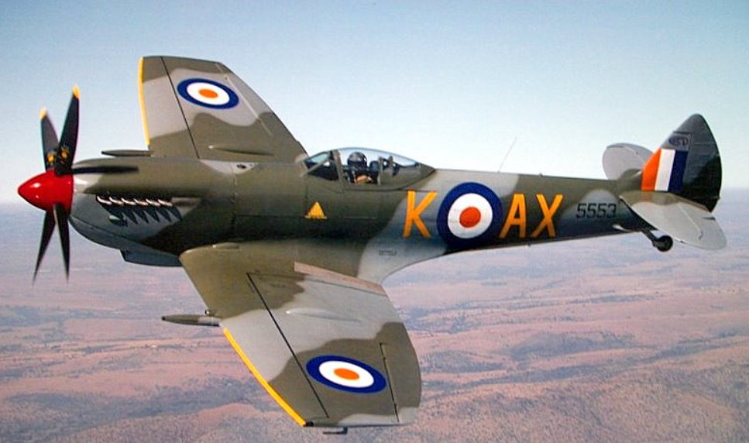
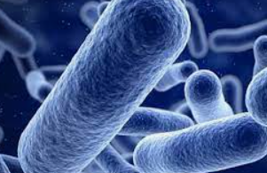
Year 6 Newsletter
Classes 6L and 6H
This term the children will be exploring the following topics:
In Science, we will be learning about ‘Living things and their habitats’. We will be investigating how we classify living things around us including: animals, plants and even microorganisms. We will be classifying these items into different groups making links between them.

How can parents help?
During our geography and art sessions, we will be studying the local area. When you are out and about in Widnes, it would be great if you could highlight the different areas and changes in development of Widnes architecture and landmarks over the years.

In Maths, some of the things we will practise are:
- Number – place value.
- Number – addition, subtraction, multiplication and division.

We will be studying and building on the skills which have been acquired over Key Stage 2, applying these skills to numbers to 10 million!

In Literacy: We will be reading Trash.
Trash is a brilliant novel which takes place in South America. The story follows three dumpsite boys who discover a brilliant and exciting treasure. They need to follow the clues and stay ahead of the police to ensure they collect their treasure and preserve their lives.

This half-term in History we will be studying both World Wars and their effects on the local area particularly Liverpool. We will be looking at what led Germany to start a Second World War and how it affected British people fighting and those back home. Our focus will be on how war specifically affected the local area of Liverpool.
In Geography, we will be studying maps, atlases and digital mapping to explore our local area.
In Art, we will be discovering the work of local artist Steven Scholes. Steven has created many pieces of the local area including one of St Luke’s Church which will become a focus of our unit.
In RE, we will explore the concept of how Christians mark the journey of life. We will be planning out our route of life and setting personal goals and targets for the year ahead.

In PE we will be studying the Haka and Sports Hall Athletics.
In our indoor PE sessions, we will be studying the Haka as part of our dance sessions. We will develop our use of dance techniques and knowledge of formation.
In our outdoor sessions, we will be studying a range of sports hall athletics activities including running, jumping and throwing.
Our PE days will be Monday (Outdoor) and Friday (Indoor). Please ensure that your child has the correct kit on these days.

Messages and reminders

As you start Year 6, you will be invited to several High School Open Days. Your final decision needs to be completed by the end of September. We would encourage you to visit every school in order to find the best place for your child!

