*Reception and Year 1and 2 children*

*Enter school through the infant gate.*

***Reception*** *– through Reception gates and as per Tapestry Instructions*

***Year 1*** *through the door next to the pergola and exit that way – 3:05pm*

***Year 2*** *in through the door next to the hall. Mrs Walters’ class will exit through this door, Mr Hawkins class through the single door by the Buddy bench. They will need to be collected from the same doors at 3:10pm*

*Year 3 – All entry through these gates – leave the children to walk to their classrooms*

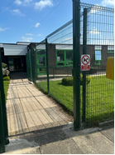

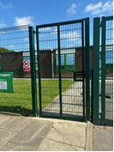

***Year 4***

Enter through the gates below and into their classroom doors. They will then leave by these doors are parents can wait for them in the area indicated below. They will leave at 3:10pm

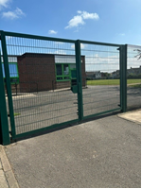

***Year 5***

They enter through the gates below and around to the side doors where they will be met. They will need to be collected on the junior yard at 3:15pm.

 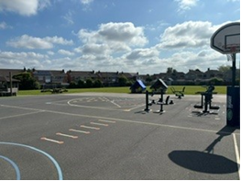

***Year 6***

*They will come in through the front door and go to the year 6 classes. They will leave by this route at 3:05pm*

As a reminder, these are the classes from September 2025

|  |
| --- |
| **New class and teacher, Sept 2025** |
| 1L – Mr Oakes |
| 1H – Miss Bruen |
| 2L – Mr Hawkins |
| 2H – Miss Walters |
| 3L – Mrs Povey / Miss Barrie |
| 3H – Miss Cameron |
| 4L – Mrs McIlhagga |
| 4H – Mrs Worthington |
| 5H – Mrs Davies |
| 5L – Mr Moore |
| 6H – Mr Crook |
| 6L - Miss Huddlestone |