**Reception Knowledge Organiser  
Summer 1: How does your garden grow?**

We are going to be learning all about growing this half term and we will be spending lots of time looking closely at similarities, differences, patterns and change. We will look at what the children already know about growing as well as what they would like to know. The children will be encouraged to ask questions in which we will enjoy finding the answers together.

**Our focus books this half-term**

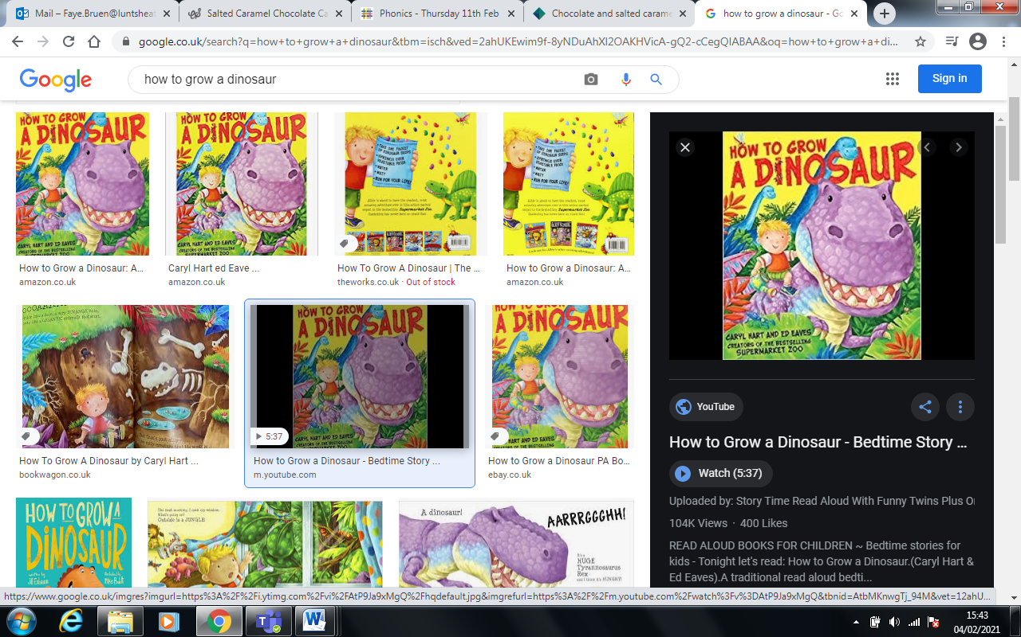

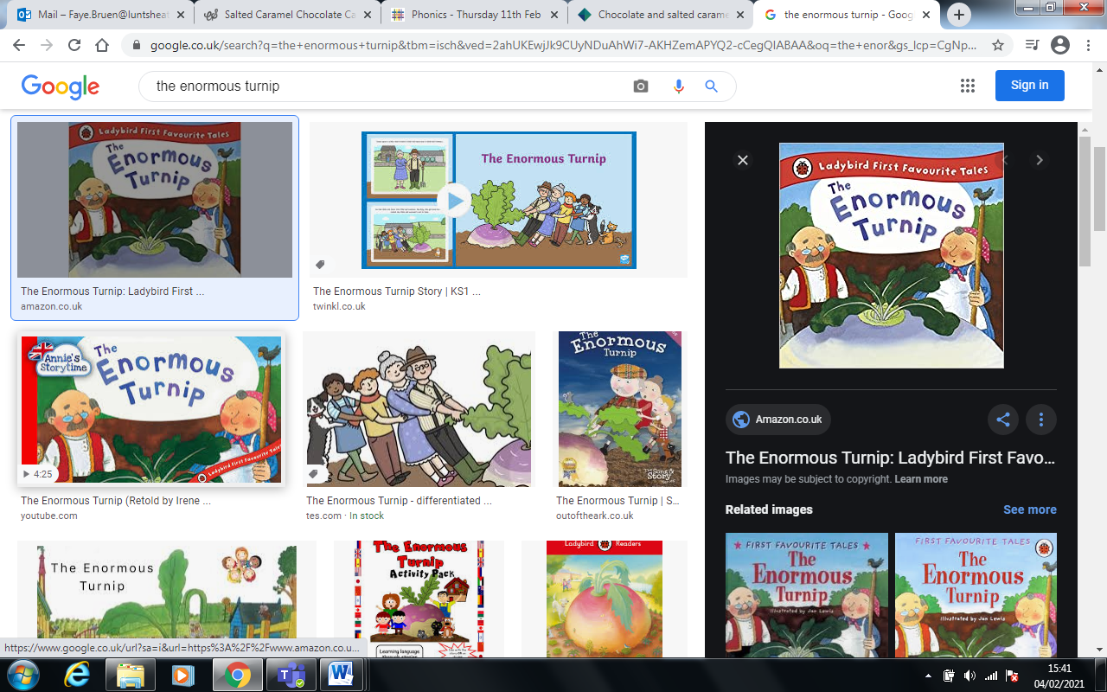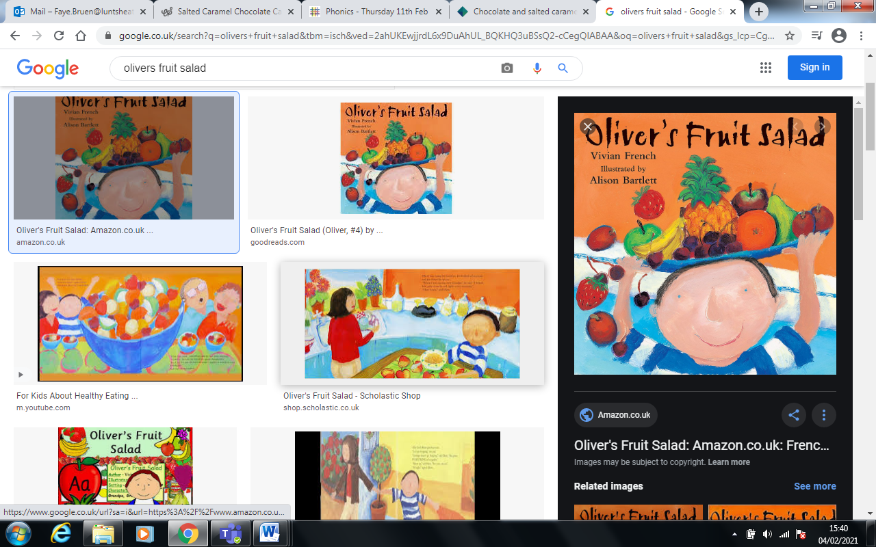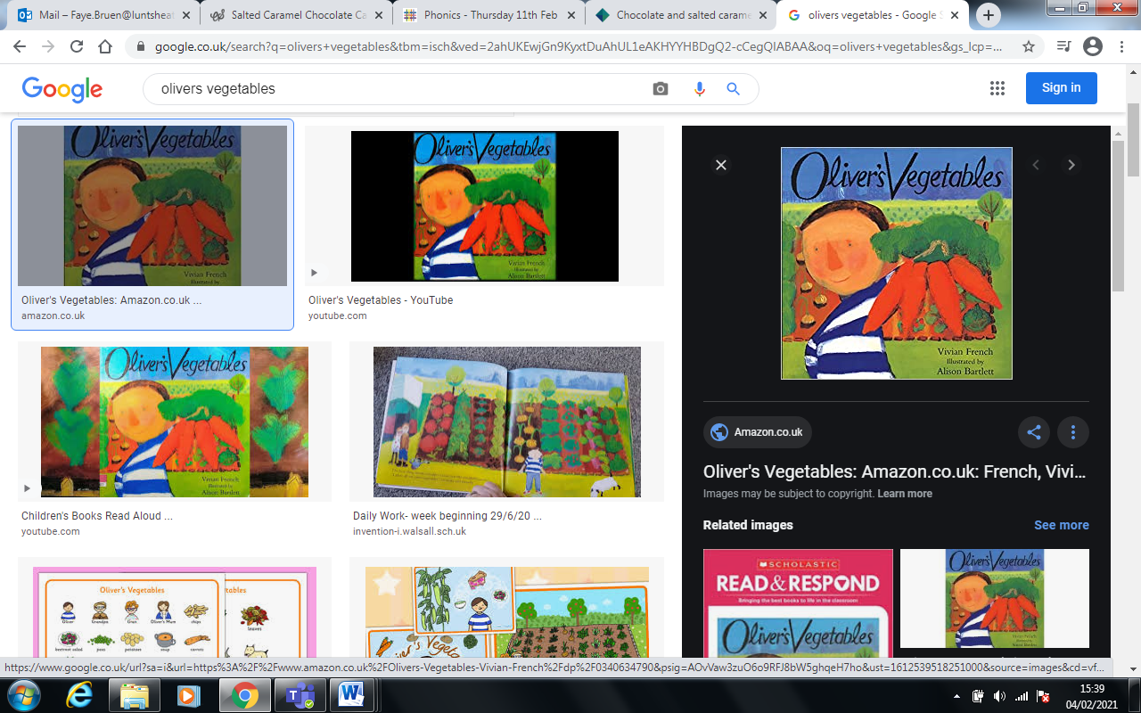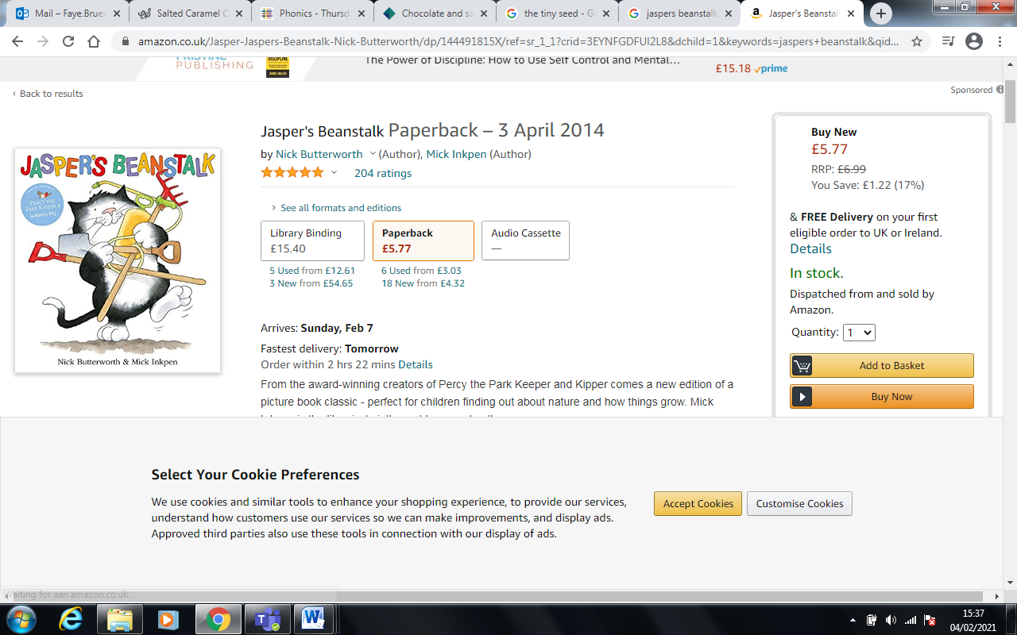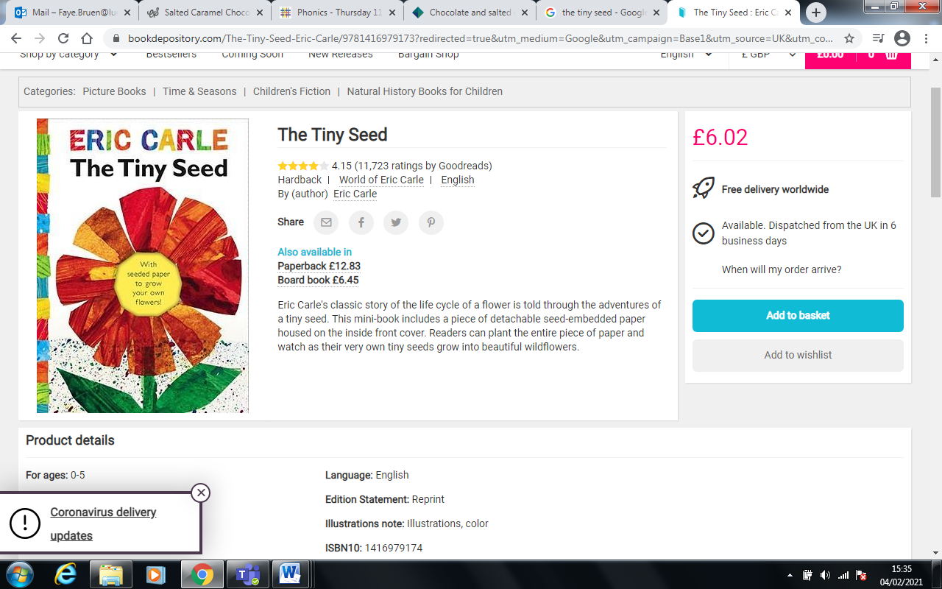

**Key Vocabulary**

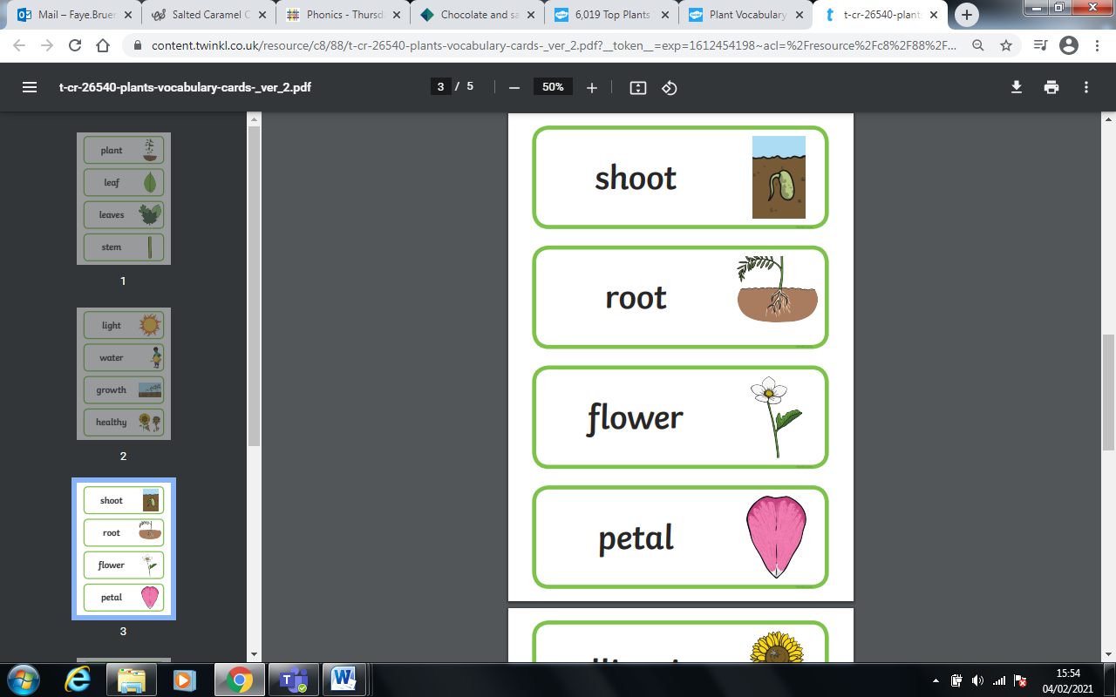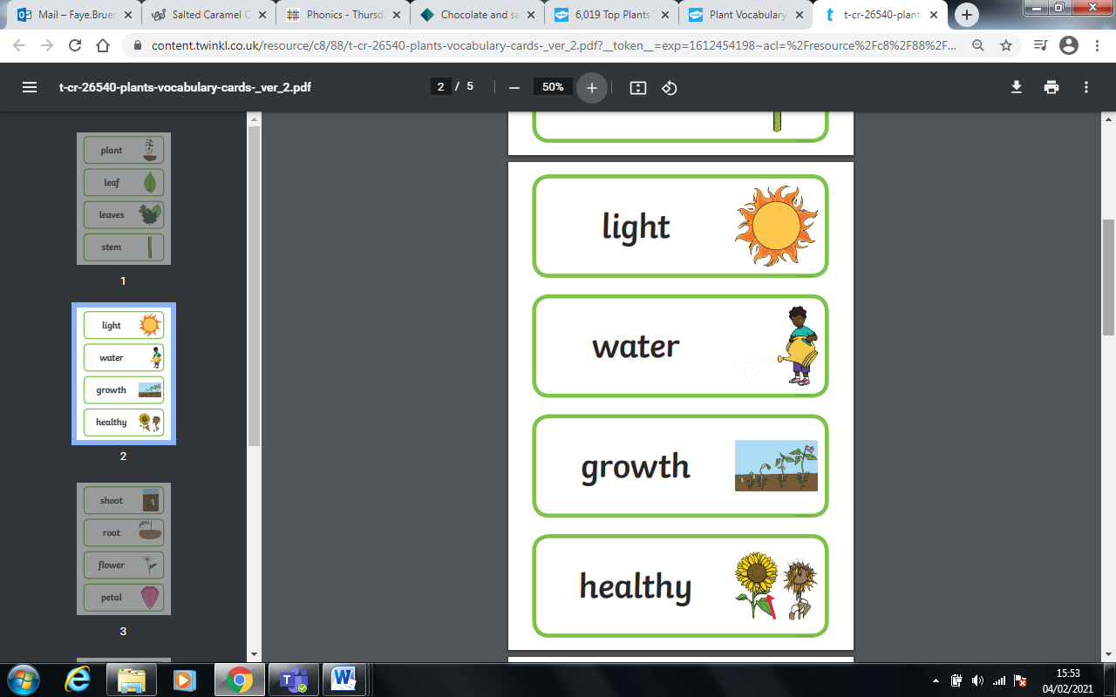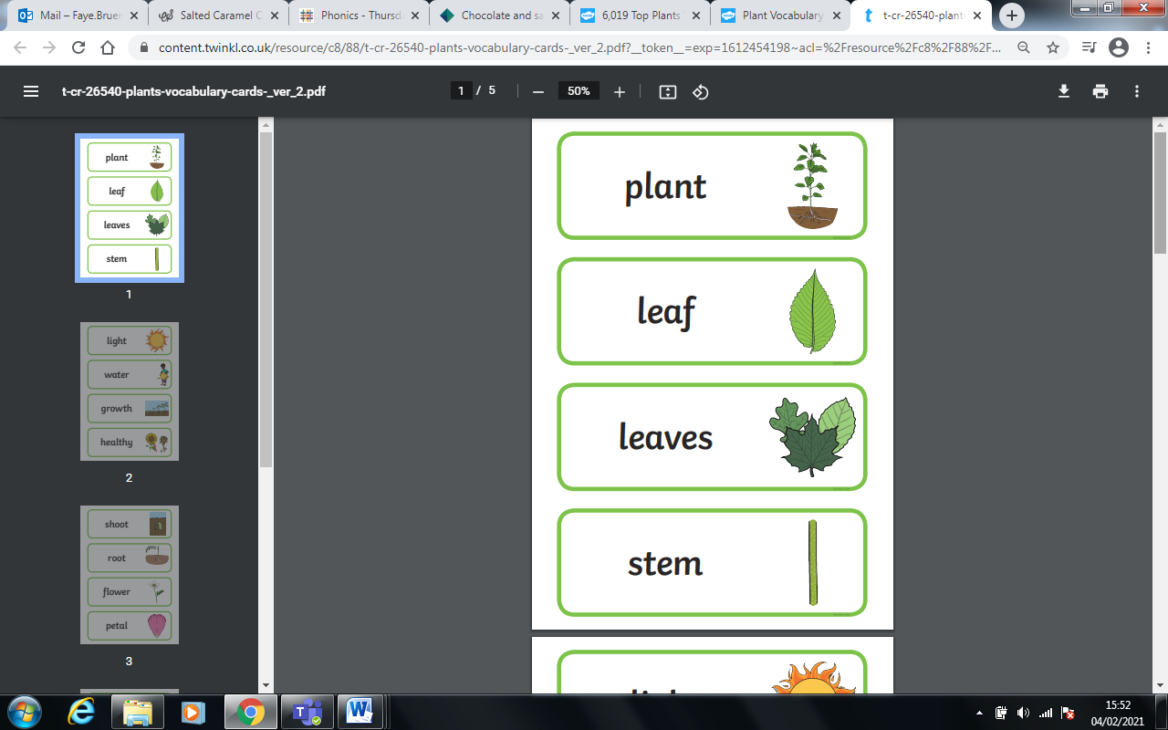

**Ideas for at home**

* Look at a picture of yourself when you were a baby and a picture of yourself now and compare.
* Look at non-fiction books and use the computer to find out about growing plants/vegetables.
* Design and make a garden using the construction blocks and resources

**Key Questions**

* What did Jack need to make the beanstalk grow?
* Where do all the flowers come from?
* Can we grow a really big flower?
* What could we grow in our vegetable garden?
* Do potatoes grow on trees?

=