When? (Key Knowledge)
Who was  Queen Victoria? | Queen of the UK from 1837 to 1901.  She is one of the longest serving  monarchs in British history (63 years). The Victorian era is named  after her.
Who was William Gossage? | He was a chemical manufacturer who established a soap making business in Widnes, England.
What is the Industrial Revolution? | The Industrial Revolution was a time of change. Products that were often made by hand began to be made by machines in factories and mills.
Possible Experiences
Go for a walk around the local area to explore different buildings.
Investigate the products used in soap making.
Capture Widnes through the Victorian period using art and design.
Experience what life was like in the Victorian period.
What? (Key Vocabulary)
Spelling | Definition/ Sentence
chemical | Any basic substance that is used in or produced by a reaction involving changes to atoms or molecules.
civilisation | Society, culture, and way of life of a particular area.
reform | Changing something to improve it.
monarchy | A system of having a king or queen rule over a country. As one king or queen dies, the power is passed to another member of the family.
factory | A building where goods are manufactured using machines.
Timeline of Key Events:
1837 – Industrial Revolution begins and Queen Victoria crowned (aged 18 years).
1844 – Factory Act states children could start work from age 8 but had to have 2 hours schooling daily.
1847 – John Hutchinson established chemical factory at Spike Island. Factory Act states women and children under 18 could only work 10 hours or less daily.
1850 – William Gossage established alkali works, producing soap.
1861 – Prince Albert dies.
1863 – First underground railway opens in London.
1867 – All factory workers limited to 10 hours work daily.
1880 – Children 5-13 required to attend school (but had to pay).
1891 – Education made free and compulsory for children 5-13.
1897 – Queen Victoria Diamond Jubilee
(50 years on the throne).
1901 – Queen Victoria dies and her
son Edward VII becomes King.

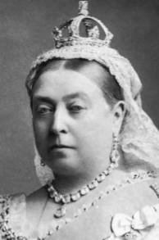

Year 3/4 Spelling Words linked to the unit of work.
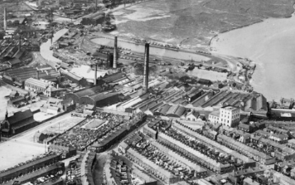
business, century, early, famous, history, important, purpose, reign, through

