Sikhism: Main Beliefs
Sikhs believe that:
- there is only one God;
- God cannot be described as either male nor female;
- God is both sargun and nirgun;
- God created the world and created people to know the difference between right and wrong;
- images of God are forbidden as is worshipping them;
- all people are equal.
Why are the Gurus important to Sikhs?
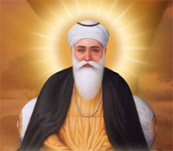
The teachings of Sikhism are based on the leadership of ten people, known as the ten Gurus. Sikhism was founded by a wise man called Guru Nanak. Guru Nanak is considered the first Sikh Guru. There were ten Gurus who spread God’s message. Each one came after the other.
Guru Nanak (First Guru)
He was born in 1469 in India. He became a shopkeeper. At the age of 30 years old, he had a spiritual experience with God and decided to spread God’s message that everyone was equal. People all over India began to follow him and were known as ‘Sikhism which means ‘learners’. Another nine gurus followed him after his death.
Guru Gobind Singh (Tenth Guru)
The tenth Guru, Guru Gobind Singh was born in 1666. He finalised the Sikh holy book - the Guru Granth Sahib - which contained the teachings of all the Gurus. He announced that, after his death, that there would be no more human Gurus, but that the book, the Guru Granth Sahib would be treated as a living guru.
The Guru Granth Sahib
The Sikh holy text. It contains the messages of all the Gurus. It is considered as a living teacher and source of authority. It is covered by a rumala when not in use. To a Sikh, it should be treated as a living guru and so they are committed to treating it with the greatest respect.
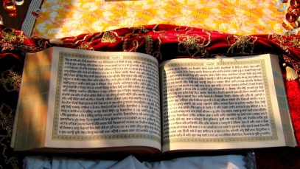
The Chaur Sahib is an implement made from yak’s hair. It is waved over the Guru Granth Sahib as a sign of respect.
Vaisakhi
Vaisakhi is Sikhism's most important festival. It marks the beginning of Hindu solar New year. It happens on the 13 or 14 April every year. After visiting the Gurdwara for a service, they have a colourful procession through the streets called the Nagar Kitan.
What? (Key Vocabulary)
Spelling | Definition/ Sentence
guru | Spiritual teacher – a person who teaches wisdom.
Gurdwara | A Sikh place of worship.
sargun | The belief that God is everywhere and in everything
nirgun | The belief that God is above and beyond everything.
Key words
Influence, role model, dedication, commitment, perseverance, resilience, equality

