Hinduism Main Beliefs
Hindus believe that:
- there is a supreme God, Brahman, who is present everywhere and that there is a part of Brahman in everyone
- life is a cycle of birth, death, and rebirth
- the next life depends on how the previous life was lived
Hinduism does not have a single holy book, but many ancient texts and scriptures.
Hindus worship in a temple called a Mandir.
Hindu dharma
The Hindu concept of dharma is often translated as ‘duty’ but can also be understood as the right way of being – behaving in a certain way because it is the right way to live. Following dharma (religious duty) is an important part of Hindu life. Belief in dharma leads to the consideration of the three ‘debts’ – duty owed to God/the deities, duty owed to teachers, and duty owed to family.
What responsibilities do family members have towards one another?
Family is seen as an important part of human life. Importance is placed on the role that each individual plays in the family and the role that the family plays in the wider community. People learn behaviours and values might from growing up within a family unit.
Family members in the story of Rama and Sita
Focus on the family members in the story of Rama and Sita and what this might teach Hindus about roles and duties in the family.
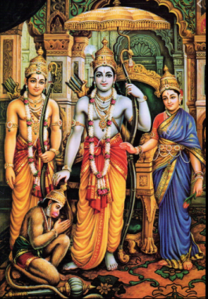
King Dasharatha keeps his promise to his wife, Rama obeys his father, Sita goes into exile with her husband, Lakshman is the loyal brother – Hanuman is not a family member, but represents the idea of devotion to God.
Raksha Bandhan
Raksha Bandhan is the Hindu festival that celebrates brotherhood and love. It is celebrated on the full moon in the month of Sravana in the lunar calendar. The word Raksha means protection, whilst Bandhan is the verb to tie. Traditionally, during the festival sisters tie a rakhi, a bracelet made of interwoven red and gold threads, around their brothers' wrists to celebrate their relationship.
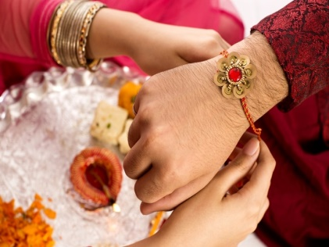
It is believed that when a woman ties a rakhi around the hand of a man it becomes obligatory for him to honour his religious duty and protect her.
What? (Key Vocabulary)
Spelling | Definition/ Sentence
Dharma | The right way of living.
rebirth | The process of being reincarnated or born again into another life.
duty | A responsibility
Mandir | A Hindu temple. Mandirs vary in size from small village shrines to large buildings, surrounded by walls.
Key words
Family, individual, community, duty, contribute, responsibility, relationship, devotion, loyal

