What? (Key Knowledge)
What does Christianity mean? | It is the name of a religion and its followers are known as Christians. Christianity is focussed on the life and teachings of Jesus Christ, who Christians to believe is the Son of God.
What do Christians believe? | Christians believe that there is only one God who created heaven and Earth. Also, that he is revealed in three different forms: (1) God the Father. (2) God the Son. (3) The Holy Spirit. Christians model their lives on the life and teachings of Jesus Christ.
Who was Jesus? | Christians believe that God sent Jesus (his son) to live as a human being, to save humanity from the consequences of its sins. Jesus travelled to spread the word of God.
Why is Christmas important to Christians? | It reminds Christians that Jesus, the Son of God, came to Earth (was born) on this day, for all people.
Why is Easter important to Christians? | It is the most important Christian festival which reflects on the following:  - Maundy Thursday – Last Supper with Jesus and his disciples (breaking of bread and wine).  - Good Friday – Jesus died on the cross (Crucifixion).  - Easter Sunday – Jesus rose from the dead (resurrection).
Possible Experiences
- Engage in role play to experience special events.
- Opportunities for discussion to explore the faith.
- Artwork to reflect understanding of Christianity.
What? (Key Vocabulary)
Spelling | Definition/ Sentence
Disciple | A person who followed Jesus during his life, especially one of the twelve apostles.
Bible | The Christian holy book which is divided into the old and new testaments. The new testament focuses on the life of Jesus.
Service | To serve by doing something for someone. For example, Jesus served God by spreading the word of God.
Sacrifice | To give up time and monetary values to help others. For example, Jesus sacrificed his life for his people but also, sacrificed his time, home and wealth to travel to spread the word of God (to encourage people to live better lives and continue his work).
Maundy Thursday | A Christian holy day which celebrates the last supper.
Resurrection | When Jesus came back to life after death.
The Last Supper
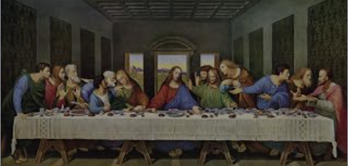
Year 3/4 Spelling Words linked to the unit of work.
appear, believe, experience, guide, heard, important, promise, purpose, special.

