What? (Key Knowledge)
What are the most important Muslim practices in life? | To follow the 5 Pillars of Islam, which reflects they put their faith first:  (1) Shahadah - Belief in one God. (2) Salah – Pray five times a day. (3) Zakah – To pay a set amount of their wealth to charity.  (4) Sawm - Fasting during the month of Ramadan.  (5) Hajj - Pilgrimage to Mecca.
What is Islam based on? | It is based on the ministry of a man named Muhammed and on the words that Allah gave to the world through Muhammed.
Why is prayer important to Muslims? | It is central to Islamic belief. They pray five times per day and each period of pray has a special name. Prayer times are fixed by the sun and change daily. Muslims wash themselves before prayer and face in the direction of Mecca whilst praying.
Why is charity important to Muslims? | Money is collected to give away to charity. This is to help the worldwide Islam community.
What places are special to Muslims? | The Muslim building for communal worship is called a mosque. It has a domed roof and is decorated in patterns and words from the Qur’an. People take off their shoes to keep it clean for pray. Women do not pray in the same place as men, there is usually a separate area for them to pray.
Possible Experiences
- Engage in role play to experience special events.
- Opportunities for discussion to explore the faith.
- Artwork to reflect understanding of the religion.
What? (Key Vocabulary)
Spelling | Definition/ Sentence
Muslim | A follower of the religion of Islam.
Qu’ran | The Muslim scripture is the Holy Qur’an. Muslims believe it is the word of God and their beliefs and practices are rooted in this sacred book.
Allah | Muslims believe there is only one God called Allah.
Muhammed | A prophet chosen by Allah.
Ramadan | The ninth month of the Muslim year, during which strict fasting is observed from dawn to sunset.
Fasting | To be deprived of all food.
Mecca | Mecca is the holiest city for Muslims.
Rak’ah | Muslim prayer positions to communicate with Allah
Pilgrimage | A journey whereby a person goes in search of new meaning about their self, others, nature or a higher good.
The Five Pillars of Islam
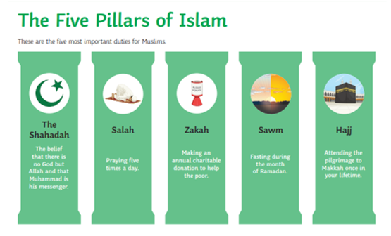
Year 3/4 Spelling Words linked to the unit of work.
believe, experience, guide, heard, important, position, possession, promise, purpose, special.

