What? (Key Knowledge)
Who is Paul Cézanne? | A post-impressionist artist. He was born in 1839, in Aix-en-Provence, in the South of France. He died there in 1906. Cézanne was a French painter whose work spanned more than 40 years.
What does impressionism mean? | A style or movement in painting originating in France in the 1860s. It generally reflects the visual impression of the moment, especially in terms of light and colour.
Why was Paul Cézanne a significant artist? | He produced more than 900 oil paintings and 400 watercolours, over 200 of them being still life paintings. His work demonstrated a mastery of design, colour, and composition. His brush strokes were clearly recognisable. Cézanne’s work influenced other artists, especially Pablo Picasso and Henri Matisse.
What is still life painting? | This is a work of art which reflects an object/subject that does not move. The objects/subjects are either natural or man-made.
Possible Experiences
- To explore an artist’s life through discussion.
- To experiment with a variety of techniques and media relating to the artist’s work.
- To use a sketchbook to sketch still life art, through observations of real-life objects.
- To showcase finished artwork.
What? (Key Vocabulary)
Spelling | Definition/ Sentence
Shape | The outline of the still-life objects.
Line | Defines shape - the outer edge of something.
Proportion | The size of an object or different parts of a piece of art in relation to each other.
Overlap | The way some objects tuck underneath each other.
Shading | Ways to show the tones in your subject. For example, hatching, stipple, smudge etc.
Gradual | Changing by small amounts.
Contrast | Opposite elements (light vs dark, rough vs smooth).
Tone | How light or dark a shape is.
Paul Cézanne and his Still Life Artwork
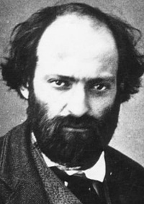
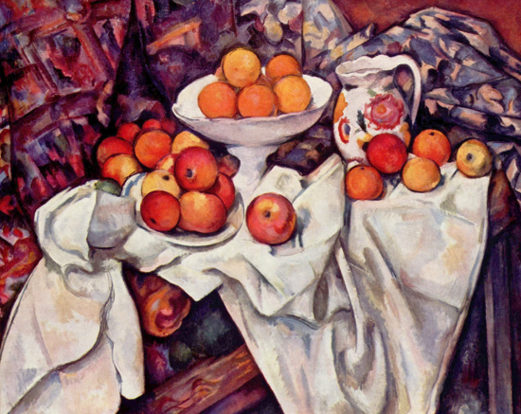

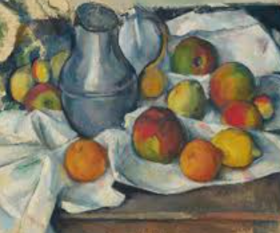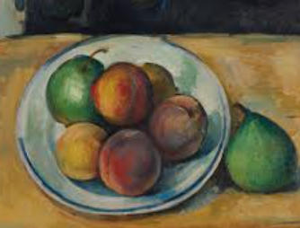
Year 3/4 Spelling Words linked to the unit of work.
Actual, centre, century, certain, circle, experience, famous, fruit, history, material, natural, notice, position, potatoes, various.

